
Cortes-800 40 terawatt laser system
TABLE OF CONTENTS
PAGE
LIST OF TABLES iv
LIST OF FIGURES v
PROPOSAL
Quotation 1
Installation and Performance 2
Proposal Summary 3
Cortes-800 Technical Specifications 3
Contents of System* 4
Customer Requirements 5
System Description 6
Optical Architecture 6
Electrical Architecture 7
Timing Diagram 8
System Requirements 9
Electrical 9
Physical 9
Environmental Conditions 10
Cooling and Compressed Air 10
Humidity and Clean Room 10
Vibration 11
Instrumentation 11
System Components 12
STAGE 1 12
STAGE 1 Output 13
Component Specifications 14
STAGE 2 15
STAGE 2 Output 16
Component Specifications 17
STAGE 3 18
STAGE 3 Output 18
MEASUREMENT SYSTEM 18
Shack-Hartmann Wavefront Analyzer. 19
RINCON Cross-correlator. 19
REEF-SS Single-Shot Autocorrelator 19
AVOCA-20 SPIDER 20
Power Meter 21
USB4000 Spectrometer. 21
Technical Documents 22
Quality Assurance 23
Technical Tests 23
Warrenty and service Information 24
Reference Systems 26
CORTES-800 2 TW 26
JAWS-1240 1 TW 27
Del Mar Photonics 31

list of tables
PAGE
Table 3.1. CORTES-800 40 TW Technical Specification 3
Table 5.1. Electrical Requirements. 9
Table 5.2. Cooling and Compressed Air Requirements 10
Table 6.1. Oscillator output 13
Table 6.2. Wedge-10 output 13
Table 6.3. FINESSE 6 W Specifications 14
Table 6.4. SURELITE I-10 Specifications 14
Table 6.5. PISMO-8 Pulse Picker Specifications 15
Table 6.6. AOPDF DAZZLER HR-800/T1 Specifications 15
Table 6.7. PRE-AMPLIFIER output 16
Table 6.8. POWER AMPLIFIER output 16
Table 6.9. POWERLITE 9010 17
Table 6.10. POWERLITE PLUS 2 J 17
Table 6.11. Stage 3 Output 18
Table 6.12. RINCON Cross-correlator Specifications 19
Table 6.13. REEF-SS Single-Shot Autocorrelator Specifications 20
Table 6.14. AVOCA-20 SPIDER Specifications 20
Table 10.1. CORTES-800 2 TW Technical Specifications 27
Table 10.2. JAWS-1240 1 TW Technical Specifications 29

list of figures
PAGE
Figure 4.1. Typical table layout for CORTES-800 40 TW 6
Figure 4.2. Delay synchronization schematic. 8
Figure 6.1. Example layout of standard Wedge MPA (1109 x 609 mm²) 13
Figure 10.1. Conceptual schematic for CORTES-800 2 TW 26
Figure 10.2. CORTES-800 2 TW system 27
Figure 10.3. Conceptual schematic for JAWS-1240 1 TW 28
Figure 10.4. JAWS-1240 1 TW system 30

SEction 1
Quotation
Customer:
YOUR NAME HERE

Date | 05/01/2010
Quotation No | DMP100501
Payment | - Within fifteen (15) days following execution of agreement by both parties, CUSTOMER shall pay Seller 30% of the total system cost.  - Within fifteen (15) days following agreement by both parties of a Detailed Design Review, CUSTOMER shall pay Seller 20% of the total system cost.  - Within fifteen (15) days following agreement by both parties of a System Validation Review along with Factory Acceptance at the Seller’s site, CUSTOMER shall pay Seller 20% of the total system cost.  - Within fifteen (15) days following agreement by both parties of an Acceptance Test in the CUSTOMER facility, CUSTOMER shall pay Seller the final 20% of the total system cost.
Validity | Until further notice

Item | Description | Units | Price/unit  (USD) | Total  (USD)
1 | Cortes-800 40 TW laser system | 1 | 1.9 million | 1.9 million

Postage, packing and insurance will be added at cost
All prices quoted in United States dollars
All prices exclusive of taxes
Section 2
Installation and Performance
System assembly and integration of supplier components will be performed at Del Mar Photonics facilities in San Diego, California. Prior to delivery to customer all agreed upon performance parameters will be verified at the Del Mar Photonics facility. Final system installation at the customer prepared facility will be performed by Del Mar Photonics personnel. Performance of system to agreed upon specifications will be dependent on customer prepared facility meeting pre-determined space and environmental requirements.

Performance tests to verify the technical specifications detailed in Table 3.1 will be performed on site using standard industry procedures, mutually agreed upon by Del Mar Photonics and the customer. Performance will be partly dependent

Section 3
Proposal Summary

Cortes-800 Technical Specifications
Table 3.1. CORTES-800 40 TW Technical Specification
Parameter | Value
Wavelength | 795 ± 15 nm
Pulse Duration | < 30 fs
Repetition Rate | 10 Hz
Output Energy | > 1 J
Energy Stability | < 2% RMS
Beam Size | ~ 7.5 mm
STREHL Ratio | > 0.8 with Deformable Mirror (DM)
Spatial Mode – M2 | < 1.6
Polarization | > 100:1
Contrast Ratio
Replica | > 106:1
@ 1 ps | > 104:1
@ 5 ps | > 106:1
@ 10-20 ps | > 5x106:1
ASE | > 107:1

Contents of System*
- Femtosecond OSCILLATOR:
- TRESTLES-20 Ti:sapphire oscillator
- Pump laser for OSCILLATOR:
- FINESSE 6W: 1 unit
- 8-pass multipass WEDGE-10 consisting of:
- AOPDF pulse shaper
- GRATING STRETCHER
- First MULTIPASS AMPLIFIER
- POCKELS CELL PULSE PICKER
- Pump laser for MULTIPASS AMPLIFIER:
- SURELITE I-10: 1 unit
- SPATIAL FILTER
- Second POCKELS CELL for increased temporal contrast ratio
- Multipass PRE-AMPLIFIER consisting of:
- Mulitpass PRE-AMPLIFIER stage
- SPATIAL FILTER
- Pump laser for PRE-AMPLFIIER:
- POWERLITE 9010: 1 unit
- Multipass POWER AMPLIFIER consisting of:
- Multipass POWER-AMPLIFIER stage
- VACUUM SPATIAL FILTER
- Pump lasers for POWER-AMPLIFIER:
- POWERLITE PLUS 2J: 2 units
- VACUUM COMPRESSOR consisting of:
- SPATIAL FILTER
- GRATING COMPRESSOR
- DEFORMABLE MIRROR
- PULSE SYNCHRONIZATION ELECTRONICS

- MEASUREMENT system consisting of:
- Shack-Hartmann wavefront analyzer
- RINCON cross-correlator
- REEF-SS single-shot autocorrelator
- USB4000 spectrometer
- Power meter
- Necessary opto-mechanics and mirrors for system installation and measurement

*Note: Del Mar Photonics reserves the right to replace any components listed in this proposal with items of equal or greater quality from alternative vendors based on price or performance needs. Final system layout and design may deviate from initial proposal.

Customer Requirements
Del Mar Photonics will provide all materials and components necessary for system assembly and testing. Site preparation and maintenance will be the responsibility of the customer, this includes:
- Environmental control (see System Requirements)
- Electrical wiring, outlets and protection
- Water supply and connector sites
- Optical tables
- Sufficient room space for installation and operation of system

Section 4
System Description

Optical Architecture
A typical CORTES-800 40 TW optical layout is shown in Figure 4.1.
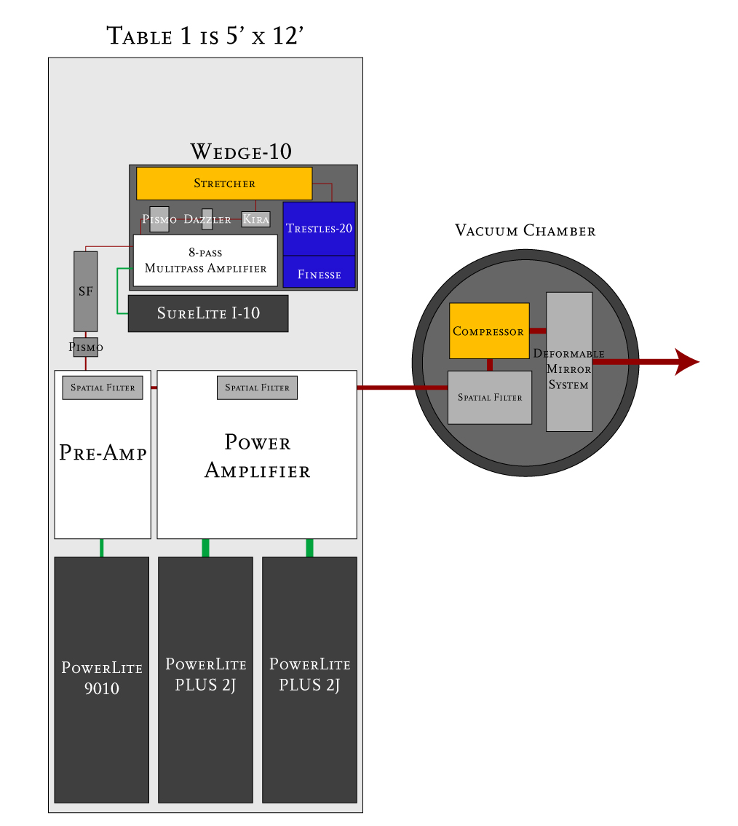
Figure 4.1. Typical table layout for CORTES-800 40 TW

The optical components of CORTES-800 40 TW, excluding compressor, occupy a single 5’ x 12’ optical table. The vacuum chamber contains the final spatial filter, compressor, and deformable mirror system. Each component has the following dimensions:
- WEDGE-10: 1106 x 606 mm²
- SURELITE I-10 (1 unit): 775 x 178 mm²
- POWERLITE 9010 (1 unit): 1190 x 457 mm²
- POWERLITE PLUS 2J (2 units): 1190 x 457 mm²
- PRE-AMPLIFIER: 467 x 82 mm²
- POWER AMPLIFIER: 967 x 82 mm²
- VACUUM CHAMBER: Approximately: 1250 x 1250 mm²

Electrical Architecture
Refer to System Requirements.

Timing Diagram
The synchronization electronics controlling the trigger delays for CORTES-800 40 TW are controlled via a PC running LabView, as shown in Figure 4.2. The oscillator signal is fed into the synchronization electronics and sets the primary synchronization signal. The synchronization electronics then sends signals to trigger the two pulse pickers and four amplifier pumps. Each signal must be delayed by the appropriate amount corresponding to the time it takes for the pulse to travel to the corresponding stage of the amplifier.
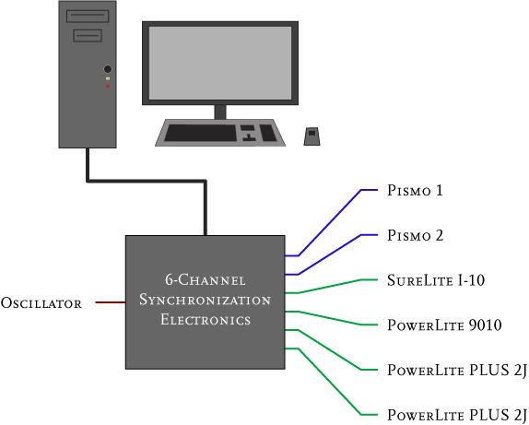
Figure 4.2. Delay synchronization schematic.

Section 5
System Requirements

Electrical
Table 5.1. Electrical Requirements.
Component | Electrical Requirement
Finesse 6W | 120 VAC
AOPDF | 120 VAC
Synchronization Electronics | 120 VAC
SureLite I-10 | 220 or 240 V, single Φ, 10 A
PowerLite 9010 | 220 or 240 VAC, single Φ, 14 A
PowerLite PLUS | 220 or 240 VAC, single Φ, 21 A
Vacuum Chamber | To be determined during DESIGN REVIEW
Deformable Mirrors | To be determined during DESIGN REVIEW

Physical
All optical components of CORTES-800 40 TW, excluding the VACUUM COMPRESSOR, fit on a single 1.5 x 3.6 m² optical table (for a typical standard layout). An additional 1 m of space surrounding the optical table should be available for control units of pump lasers, AOPDF, and synchronization electronics. The VACUUM COMPRESSOR will require an additional 3 m² area for the VACUUM CHAMBER and VACUUM control system. The MEASUREMENT system will require 1.5 m² area on a suitable optical table located close to the VACUUM CHAMBER.

Environmental Conditions

Cooling and Compressed Air
Table 5.2. Cooling and Compressed Air Requirements
Component | Requirement
SureLite I-10 | Closed loop water to air heat exchanger: external cooling water not required (1 gal deionized water)
PowerLite 9010 | 1 - 2 GPM (gallons / minute) at 40 - 60 PSI pressure drop  Temperature <22° C / 70° F (higher flow rate for higher temperature)
PowerLite PLUS | 1 - 2 GPM (gallons / minute) at 40 - 60 PSI pressure drop  Temperature <22° C / 70° F (higher flow rate for higher temperature)
VACUUM CHAMBER | To be determined during Design Review

Humidity and Clean Room
In order for the system to operate at its design specifications, certain environmental conditions must be maintained. Room temperature and humidity should be maintained at constant levels at all times. In order to avoid damage to optical and electrical components, humidity levels close to 50% should be maintained year round. As the alignment of many of the system subcomponents can be adversely affected by temperature changes it is important to maintain a constant temperature with variations of no more than ± 1 °C. Stability and alignment can also be adversely affected by airflow across the system components. Such flow should be kept to an absolute minimum.

Vibration
The vibrations on the optical tables have to be lower than:
- 10-4 g²/Hz in the 1 – 30 Hz range.
- 10-5 g²/Hz in the 30 – 100 Hz range.
- 10-6 g²/Hz in the 100 – 1 000 Hz range.

Instrumentation
All instruments necessary to operate and maintain the system at the design specifications will be included with the system. Several additional items may facilitate day to day use of the system:
- Additional Infrared viewer
- Infrared viewing card
- Additional storage oscilloscope
- Black and white CCD cameras
- USB controlled fiber spectrometer operating in the 800 nm range with spectral resolution on the order of 1 nm.

Section 6
System Components

STAGE 1
The initial stage of the system will consist of the TRESTLES-20 femtosecond oscillator pumped with a 532 nm, 6 W FINESSE (Laser Quantum) laser. Generated 20 fs pulses will then be temporally lengthened with a single grating pulse stretcher to 400 ps. To pre-correct for spectral changes incurred as pulses pass through the system the stretched pulses will pass through an acousto-optic programmable dispersive filter (AOPDF) DAZZLER (Fastlite). The AOPDF will compensate for gain narrowing and wavelength shifting in the amplification stages and for dispersion due to propagation through system components.

Before insertion into the first amplification stage a Del Mar Photonics PISMO Pockels cell pulse picker (this will be the first timing trigger, see Section 4) will be used to gate single pulses at a repetition rate of 10 Hz from the oscillator pulse train. The stretched, shaped and picked pulses will then be amplified by a WEDGE-10 multi-pass amplifier (MPA). The WEDGE-10 amplifier will be pumped with a SURELITE I-10 (Continuum, Inc.) pump laser.

With the exception of the SURELITE I-10 pump laser all STAGE 1 subcomponents will be housed in a single box (111 x 61 cm²).
Figure 6.1. Example layout of standard Wedge MPA (1109 x 609 mm²)

STAGE 1 Output
Table 6.1. Oscillator output
Pulse Duration | 20 fs
Center Wavelength | 800 nm
Pulse Energy | 5 nJ
Repetition Rate | 100 MHz

Table 6.2. Wedge-10 output
Pulse Duration | 400 ps
Center Wavelength | 800 nm
Pulse Energy | 2 mJ
Repetition Rate | 10 Hz

Component Specifications
Table 6.3. FINESSE 6 W Specifications
Power | > 6 W
Wavelength | 532 nm
Beam size | 2.5 mm
Transverse mode | TEM₀₀
Divergence | < 0.4 mrad
M2 | < 1.1
Power stability (rms) | < 1.0 %
Noise (1Hz-6MHz - rms) | < 0.5 %
Polarization ratio | 100:1

Table 6.4. SURELITE I-10 Specifications
Pulse energy | 200 mJ
Pulse width | 4-6 ns
Repetition Rate | 10 Hz
Divergence | 0.6 mrad
Pointing Stability | 30 +/-microrads
Energy Stability | 3.5 %

Table 6.5. PISMO-8 Pulse Picker Specifications
Output Voltage | 4 - 8 kV
Repetition Rate | 1 / 5 / 10 / 15 / 25 kHz
Rise Time | < 1 ns
Pulse Width | < 4 ns
Jitter | < 0.2 ns
Trigger Input | optical or TTL electrical
RF synch Input | 10 - 150 MHz
Adjustable Delay | 0 - 4 µsec

Table 6.6. AOPDF DAZZLER HR-800/T1 Specifications
Wavelength tuning range | 720 nm to 920 nm*
Instantaneous bandwidth | from 0.3nm up to 200 nm maximum
Spectral resolution @ 800 nm | 0.3 nm
Number of programming points | 200 on 60 nm bandwidth
Intensity control dynamic range | > 55 dB
Maximum programmable delay | > 6 psec
Efficiency | > 50% on a 50nm bandwidth
Optical power limit | 100 MW/cm²
Waveform refreshing time | Option T1: USB 1.5 sec

STAGE 2
After the initial amplification stage the pulses will be passed through a spatial filter to increase the beam diameter and improve the spatial quality of the beam. A second PISMO Pockels cell will be used to increase the temporal contrast ratio and to protect STAGE-1 from back reflections. The spatially expanded pulses will pass through a PRE-AMPLIFIER stage pumped with a POWERLITE 9010 (Continuum, Inc.). Pulse energy will be increased to 200 mJ in the PRE-AMPLIFIER and again spatially filtered to maintain beam quality before insertion into the final POWER AMPLIFIER stage. The POWER AMPLIFIER will be pumped by dual POWERLITE PLUS 2 J (Continuum, Inc.) pump lasers. Pulses will exit the POWER AMPLIFIER with approximately 2 J of energy and pulse lengths of 400 ps.

STAGE 2 Output
Table 6.7. PRE-AMPLIFIER output
Pulse Duration | 400 ps
Center Wavelength | 800 nm
Pulse Energy | 200 mJ
Repetition Rate | 10 Hz
Table 6.8. POWER AMPLIFIER output
Pulse Duration | 400 ps
Center Wavelength | 800 nm
Pulse Energy | 2000 mJ
Repetition Rate | 10 Hz

Component Specifications
Table 6.9. POWERLITE 9010
Pulse energy | 1000 mJ
Pulse width | 4-8 ns
Repetition Rate | 10 Hz
Divergence | 0.45 mrad
Pointing Stability | 30 +/-microrads
Energy Stability | 3.0 %
Table 6.10. POWERLITE PLUS 2 J
Pulse energy | 2000 mJ
Pulse width | 4-6 ns
Repetition Rate | 10 Hz
Divergence | 0.45 mrad
Pointing Stability | 30 +/-microrads
Energy Stability | 3.0 %

STAGE 3
Pulse compression will take place within a sealed vacuum chamber with a dielectric grating compressor. Grating position, and thus final pulse duration, will be adjusted with the help of computer controlled motorized stages. A deformable mirror (DM) coupled with a Shack-Hartmann wavefront sensor will be used to correct wavefront distortions in order to achieve a Strehl ratio of better than 0.8. Full final output specifications are given in Table 3.1

STAGE 3 Output
Table 6.11. Stage 3 Output
Grating efficiency | 65%
Pulse Duration | 25 fs
Center Wavelength | 800 nm
Pulse Energy | 2000 mJ
Repetition Rate | 10 Hz
Strehl Ratio | > 0.8

MEASUREMENT SYSTEM
A number of monitoring and measurement instruments will be included and integrated with the system. A power meter with a detector head capable of measuring a 10 Hz repetition rate laser with output up to 30 W of average power will be used to measure the output of the amplifier pump lasers and amplification stages. Several devices will be used to measure the properties of the output pulse. A Shack-Hartmann wavefront analyzer will be used to measure wavefront distortions in the output pulses, and this information will be used to set the DM to correct the wavefront. A Del Mar Photonics RINCON third order cross-correlator will be used for contrast ratio measurements over an extended temporal range (0.9 ns). Spectral phase measurements will be made with an AVOCA-20 SPIDER system. The spectral phase information from the AVOCA-20 will be used to set the pre-corrections of the AOPDF, installed after the oscillator in STAGE 1. Pulse length will be determined with a REEF-SS single-shot autocorrelator. A spectrometer for monitoring the output spectrum will also be included.

Shack-Hartmann Wavefront Analyzer.
Used for wavefront measurements and feedback to DM.

RINCON Cross-correlator.
The new third order cross-correlator has been specifically developed for measuring a wide array of output parameters from ultrafast laser systems including: contrast ratio of laser pulses, determining pulse pedestal, pre- and post-pulses, and amplified spontaneous emission in femtosecond systems. It also provides information about the third-order cross-correlation function of pulse intensity on a femtosecond scale and can be used for alignment of high power femtosecond lasers.

Table 6.12. RINCON Cross-correlator Specifications
Wavelength | 700-900 nm
Pulse width | 20 fs or greater
Dynamic range | 10⁹
Wavelength bandwidth | 100 nm
Temporal range | 950 ps
Repetition rate | < 3 kHz
Input polarization | linear-horizontal
Resolution | 100 fs
Interface | USB

REEF-SS Single-Shot Autocorrelator
The Single Shot Autocorrelator (SSA) Model Reef-SS 20 was designed to monitor the pulse width of amplified ultrafast systems with output energies > 30μJ in the range of 20 fs to 200 fs and wavelength range 750-850 nm. The Reef-SS 20 is compatible with all commercial Solid State and dye amplifier systems.

Table 6.13. REEF-SS Single-Shot Autocorrelator Specifications
Spectral range: | 750 – 850 nm
Temporal range: | 20 – 200 fs
Spatial mode of input beam: | TEMoo
Input polarization: | horizontal
Pulse energy: | >1.5 nJ at repetition rate 70 MHz >40 μJ at repetition rate 1-10 Hz.
Nonlinear crystal: | 1.5 mm KDP, type I
CCD camera: | 14-bit, number of pixels 782(W) X 582(H), pixel size 8.3 X 8.3 μ
Interface | USB

AVOCA-20 SPIDER
Spectral Interferometry for Direct Electric Field Reconstruction (SPIDER) is a method for characterizing ultrashort optical pulses. SPIDER not only allows you to measure the pulse duration, but also allows you to extract the spectral phase from a femtosecond pulse.

Table 6.14. AVOCA-20 SPIDER Specifications
Wavelength range | 740-880 nm
Pulse width range | 12-40 fs
Sensitivity | 100 mW average@ 100 MHz  0.1 mJ @ Single shot
Input pulse repetition rate | 1 kHz to CW mode-locked/single-shot
Input polarization linear | horizontal
Interface | USB

Power Meter
A power meter sufficient for measurement of pump lasers and amplifier stage output is included. The power meter will be used to deduce final pulse energy based on grating efficiency.

USB4000 Spectrometer.
Used for measurements of the output spectrum in the 750-850 nm range, with a spectral resolution around 0.3.

Section 7
Technical Documents
Del Mar Photonics will provide all necessary documentation including technical specifications, manuals and warranty information for the system and all of its subcomponents.
SEction 8
Quality Assurance

Technical Tests

Performance tests to verify the technical specifications detailed in Table 3.1 will be performed on site using standard industry procedures, mutually agreed upon by Del Mar Photonics and the customer. Detailed matrices will be developed in accordance with the specifications to ensure all customer requirements are met.

Section 9
Warrenty and service Information
General Product Warranty: Our products will be free from defects in material and workmanship, and will meet the specifications stated, under normal use and service when correctly installed, operated and maintained. This product warranty is effective for the period of time stated below, unless otherwise stated in the product literature.
Warranty Periods: Gratings, optical filters and replicated mirrors (whether sold as separate products or as components of other products) are warranted for a period of ninety days from the date of shipment. Lasers and components thereof are warranted for the number of hours (or other measure of usage) specified in the operating manual for each laser or component thereof, or for one year from the date of shipment, whichever is shorter (except for the flashlamp components of lasers, and the optical and crystal components of pulsed lasers, which are warranted for ninety days). All other products are warranted for one year from the date of shipment.
Warranty Service: If you find any defects in material or workmanship or any failure to meet the specifications, you must notify Del Mar Photonics and obtain a Return Material Authorization Number (RMA#) within the warranty period by calling Del Mar Photonics at 858-876-3133, or by visiting our web site at www.dmphotonics.com. Return the product to us in proper packaging, freight prepaid, and clearly marked with the RMA#, and we will either repair or replace it, at our option. If the repairs need to be made at the Buyer site, Del Mar Photonics guarantees that service will be provided within five (5) days.
Warranty Limitations: The above warranty does not apply to products which are repaired, modified or altered by any party other than Del Mar Photonics, are used in conjunction with equipment not provided or authorized by Del Mar Photonics; or are subjected to unusual physical, thermal, or electrical stress, improper installation, misuse, abuse, accident or negligence in use, storage, transportation or handling, or tampering; or to products which are considered consumable items or items requiring repair or replacement due to normal wear and tear. On-site warranty repair is not covered under this warranty, unless otherwise stated. Del Mar Photonics' sole liability, and your sole remedy, for breach of this warranty is limited to Del Mar Photonics' repair or replacement of the product (at Del Mar Photonics' sole option). The foregoing warranty is exclusive and in lieu of all other warranties. Except as expressly provided herein, Del Mar Photonics makes no warranties, either express or implied, either in fact or by operation of law, statutory or otherwise. Del Mar Photonics expressly disclaims andy implied warranties of merchantability or fitness for a particular purpose.
Non-Warranty Repairs: If a product that is not covered by the above warranty needs repairing, we will first provide an estimate of repair charges and then repair the product upon receiving authorization from you. Repairs are warranted for ninety days. If the repairs need to be made at the Buyer site, Del Mar Photonics guarantees that service will be provided within five (5) days under the same conditions.

Section 10
Reference Systems

CORTES-800 2 TW

The CORTES-800 2 TW system was developed for P.N. Lebedev Physics Institute, Russian Academy of Sciences, in Moscow, Russian Federation. This system was designed as the front end seed for a high energy petawatt laser project using excimer lasers. Using chirped pulse amplification (CPA), a 20 fs oscillator pulse is stretched to 300 ps using a single grating stretcher. After the initial amplification stage, the 2 mJ pulse is then amplified up to 160 mJ in a power amplifier. Pulses are compressed in a single grating compressor and the final output, 50 fs, 100 mJ, 10 Hz pulses are used to seed an excimer laser petawatt amplifier.

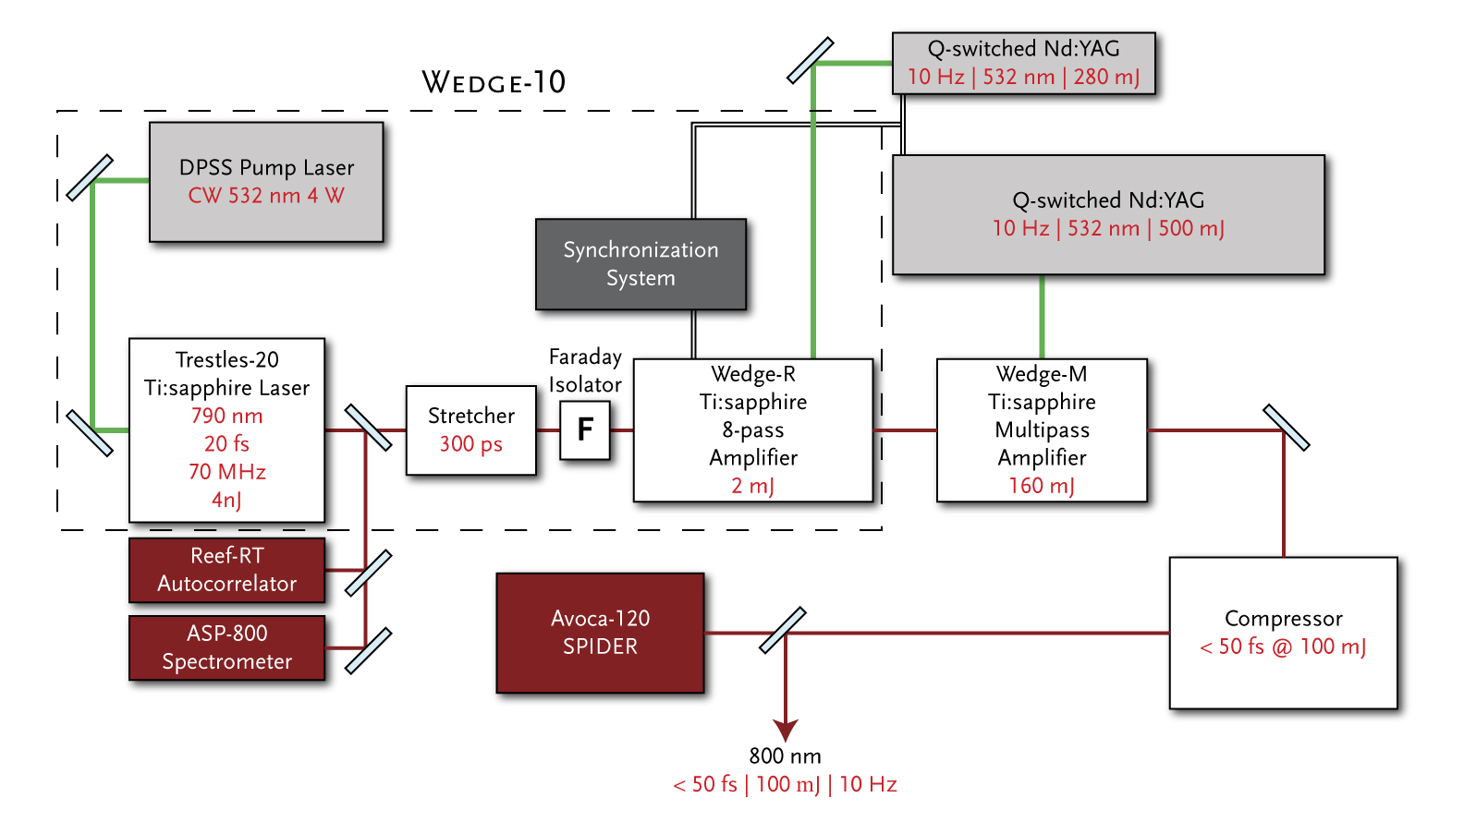
Figure 10.1. Conceptual schematic for CORTES-800 2 TW

Table 10.1. CORTES-800 2 TW Technical Specifications
CORTES-800 2 W TECHNICAL SPECIFICATIONS
Peak Power | > 2 TW
Pulse duration | < 50 fs
Output pulse energy | ≥ 100 mJ
Repetition rate | 10 Hz
Wavelength | 800±5 nm (fixed)
Energy stability | < 5%
Beam quality | M² < 1.6
Contrast Ratio
ns prepulse contrast ratio | ≥ 10⁵:1
ps prepulse contrast ratio | ≥ 10³:1 @ 1 ps
 | ≥ 10⁵:1 @ 5 ps
 | ≥ 10⁵: 1 @ 10-20 ps
Polarization of the final output beam | Linear, 100:1

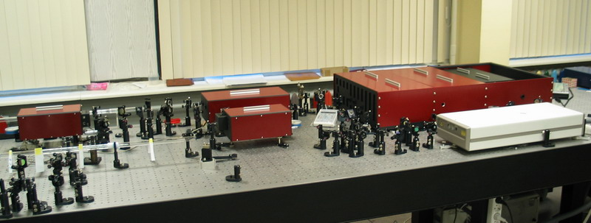
Figure 10.2. CORTES-800 2 TW system

JAWS-1240 1 TW
In addition to providing high power femtosecond laser amplifiers based on the Ti:sapphire gain medium, Del Mar Photonics also specializes in delivering high powered femtosecond lasers based on the Cr:forsterite laser medium. One such system was developed for the Institute for High Energy Densities Russian Academy of Sciences in Moscow, Russian Federation. A diode pump active element fiber laser pumps a Cr:forsterite oscillator producing 55 fs, 2 nJ pulses. After stretching to 110 ps, the pulses are amplified to 0.4 mJ in a regenerative amplifier. A 3-stage multipass pre-amplifier then increases the energy per pulse to 50 mJ. A final multipass power amplifier is then used to amplify the pulses up to 120 mJ before compressing back down to 80 fs. The final laser output is sub 80 fs, 90 mJ pulses at 10 Hz.

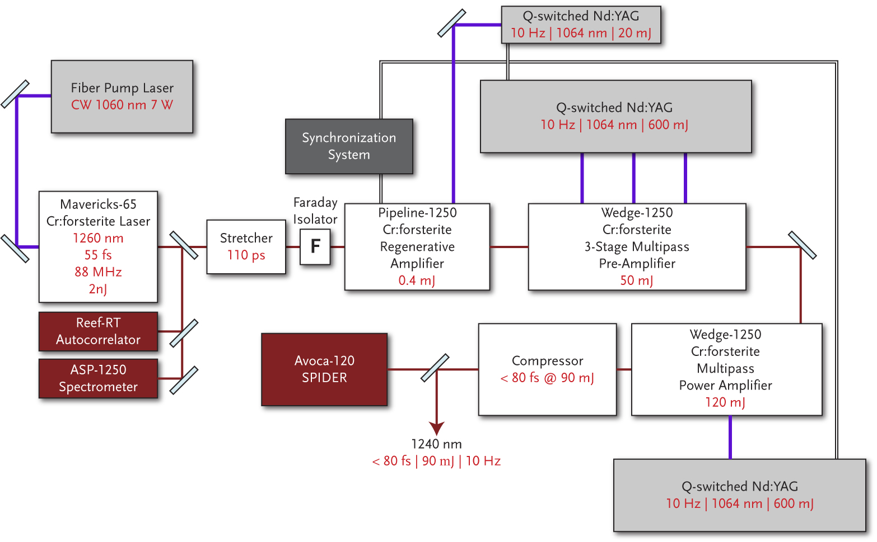
Figure 10.3. Conceptual schematic for JAWS-1240 1 TW

Table 10.2. JAWS-1240 1 TW Technical Specifications
JAWS-1240 1TW TECHNICAL SPECIFICATIONS
Peak Power | > 1 TW
Pulse duration | < 80 fs
Output pulse energy | ≥ 900 mJ
Repetition rate | 10 Hz
Wavelength | 1240±5 nm (fixed)
Energy stability | < 5%
Beam quality | M² < 1.6
Contrast Ratio
ps prepulse contrast ratio | ≥ 10⁴:1 @ 1 ps
 | ≥ 10⁶:1 @ 5 ps
 | ≥ 5x10⁶: 1 @ 10-20 ps
Polarization of the final output beam | Linear, 100:1

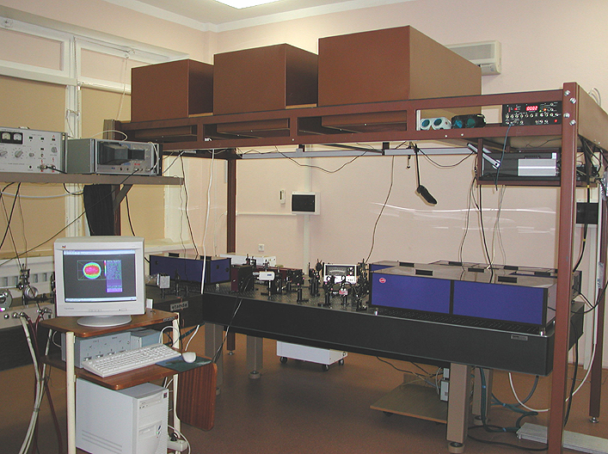
Figure 10.4. JAWS-1240 1 TW system
Del Mar Photonics
4119 TWilight Ridge
San Diego, CA 92130

